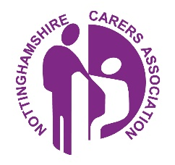
Are you a Carer?

If you are looking after someone who couldn’t cope without your help, we really would like you to let us know, so that we can ensure you receive all the support and information we can give. A carer is anyone who cares, unpaid, for a friend or family member who due to illness, disability, a mental health problem or an addiction cannot cope without their support. You are a Young Carer if you are under 18 in this role.

You can be added to the practice 'carer register' and gain access to information and support. This includes access to a named Carer Champion.

A Carer Champion is a staff member at your practice who support carers.
Jacqueline Hogg is the Practice's Carer Champion at Kirkby Health Centre.

As a Carer, you are entitled to an annual flu vaccine, a health check and can request a Carers Assessment.
Ask in your GP practice for more information.

Carers can get information, advice and tailored support by contacting the Nottinghamshire Carers Hub by calling 0115 824 8824. Lines are open Monday to Friday, 9am until 5pm.

You can speak to an experienced support worker who will provide a personalised service that meets your individual needs. The service is available to all carers and all ages.

Alternatively, you can contact them using the following methods:
Web: https://www.tuvida.org/
Email: hello@tuvida.org

Information and support for Carers (including carer’s assessments) provided by Nottinghamshire County Council can be found at
https://www.nottinghamshire.gov.uk/care/adult-social-care/carers/support-for-carers or by contacting the Customer Service Centre on 0300 500 8080

